Top Trumps

In this project you will train a computer to play a card game.

For some values on the cards, you win by having the highest number. For others, you win by having the lowest. The range of numbers for different values will vary.

The aim will be for the computer to learn how to play the game well without you having to give it a list of all the cards or tell it the rules.

Instead, you’ll try two different ways of training the computer to play the game by giving it examples of the game being played.

This project worksheet is licensed under a Creative Commons Attribution Non-Commercial Share-Alike License

http://creativecommons.org/licenses/by-nc-sa/4.0/

**What will you be doing?**

You’ll be training a machine learning model to play a Top Trumps game based on Kings and Queens of England.

Each card is based on a different King or Queen.

Each card has five numbers on it:

Reign – how long they were king or queen for

Ascension – how old they were when they became king or queen

Death – how old they were when they died

Spouses – how many husbands or wives they had

Children – how many children they had

For example:   
 

Charles I

1) He reigned for **23** years  
 If I choose this, and he was King longer than my opponent’s card, I’ll win

2) He ascended to the throne when he was **24**

If I choose this, and he became King earlier than my opponent’s card, I’ll win

3) He died when he was **48**

If I choose this, and he lived longer than my opponent’s card, I’ll win

4) He had **1** spouse

If I choose this, and he had more spouses than my opponent’s card, I’ll win

5) He had **9** children

If I choose this, and he had more children than my opponent’s card, I’ll win.

1. Go to <https://machinelearningforkids.co.uk/> in a web browser
2. Click on “**Get started**”
3. Click on “**Log In**” and type in your username and password  
   *If you don’t have a username, ask your teacher to create one for you.  
   If you can’t remember your username or password, ask your teacher to reset it for you.*
4. Click on “**Projects**” on the top menu bar
5. Click the **“Copy template**” button.
6. Import the “**Kings & Queens Top Trumps**” project template
7. Click on “**English Kings & Queens Top Trumps**” in the projects list.   
   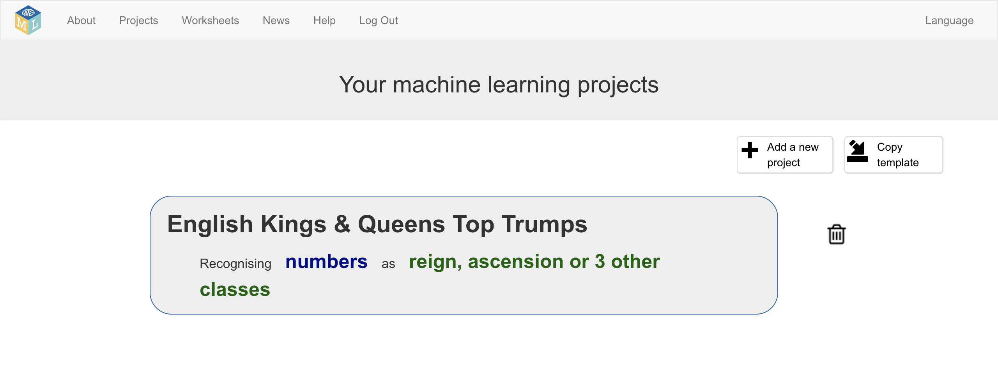
8. Click the “**Train**” button  
   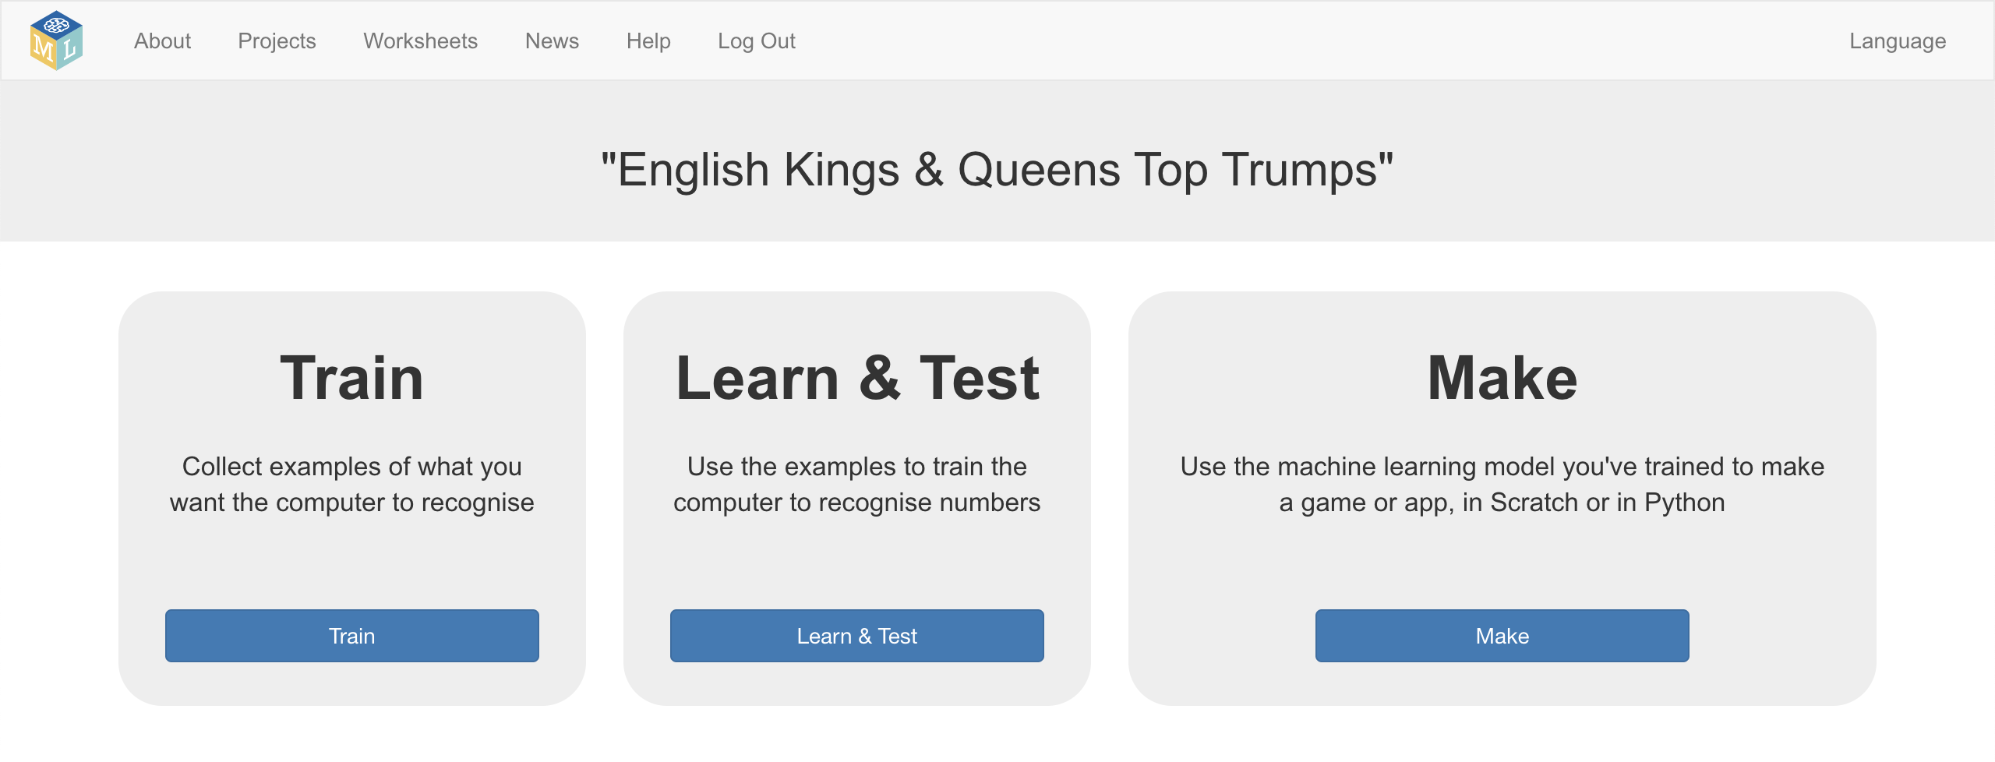
9. The project template prepares training buckets to store values from Top Trumps cards.  
   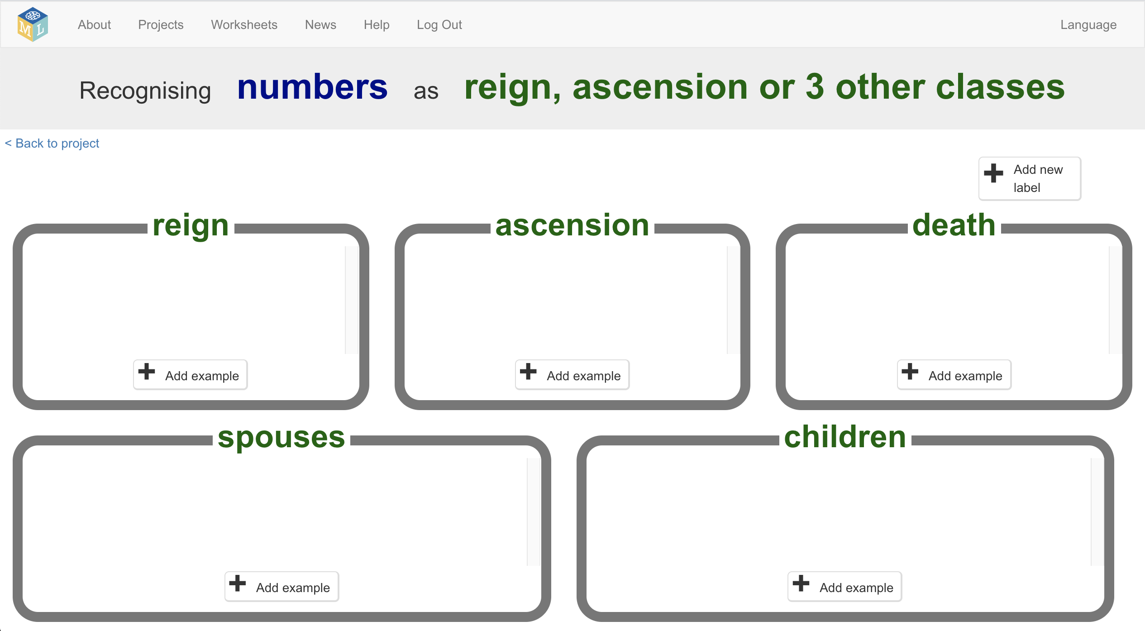
10. Click the “**< Back to project**” link in the top-right corner
11. Click the “**Make**” button
12. Click the “**Scratch 3**” button
13. Click on “**straight into Scratch**”  
    *The page warns you that you haven’t trained a machine learning model yet, but that’s okay as you’ll be using Scratch to collect training data.*   
    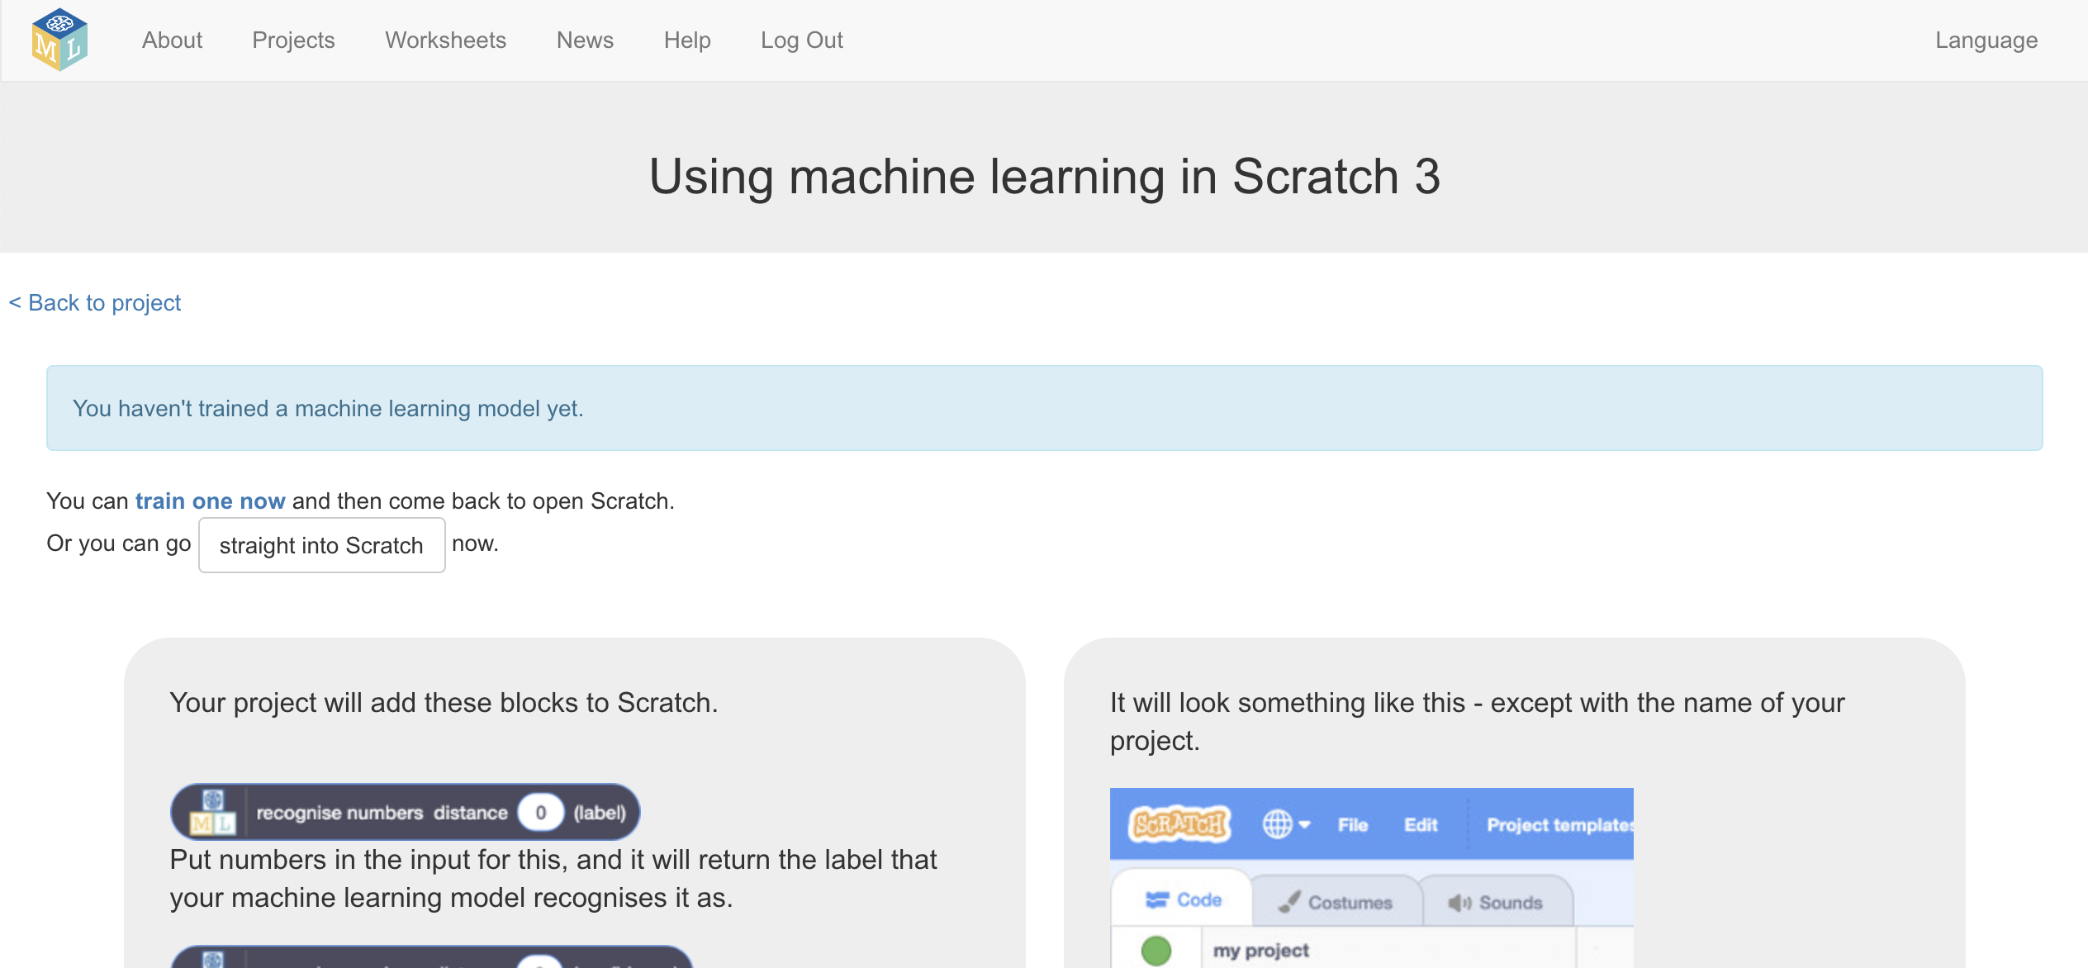
14. Click on “**Project templates**”  
    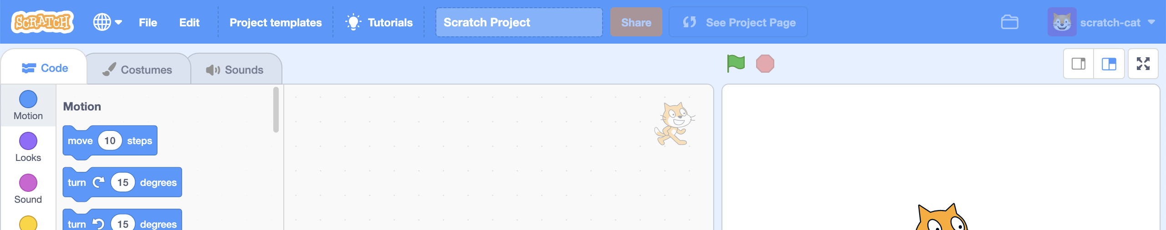
15. Click on “**Top Trumps**” to load the Top Trumps Scratch template
16. This is Top Trumps based on the Kings and Queens of England.   
    Click the **full-screen button**.   
    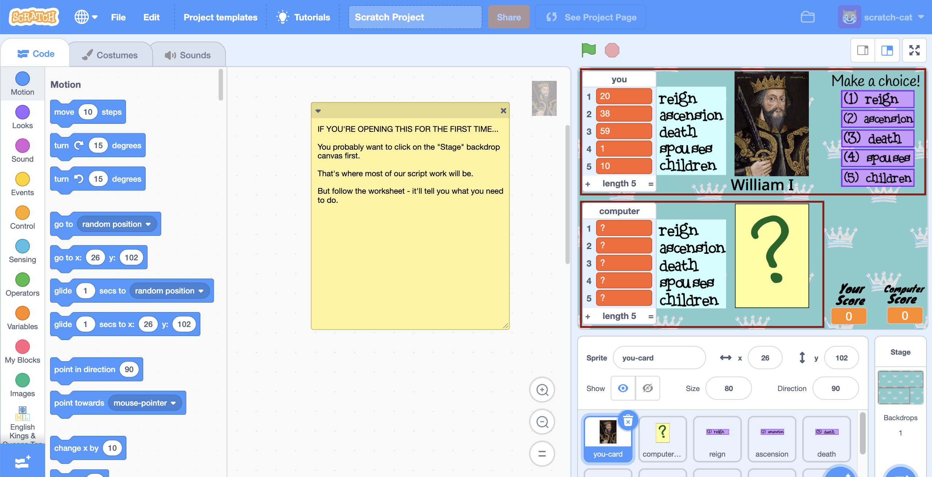
17. 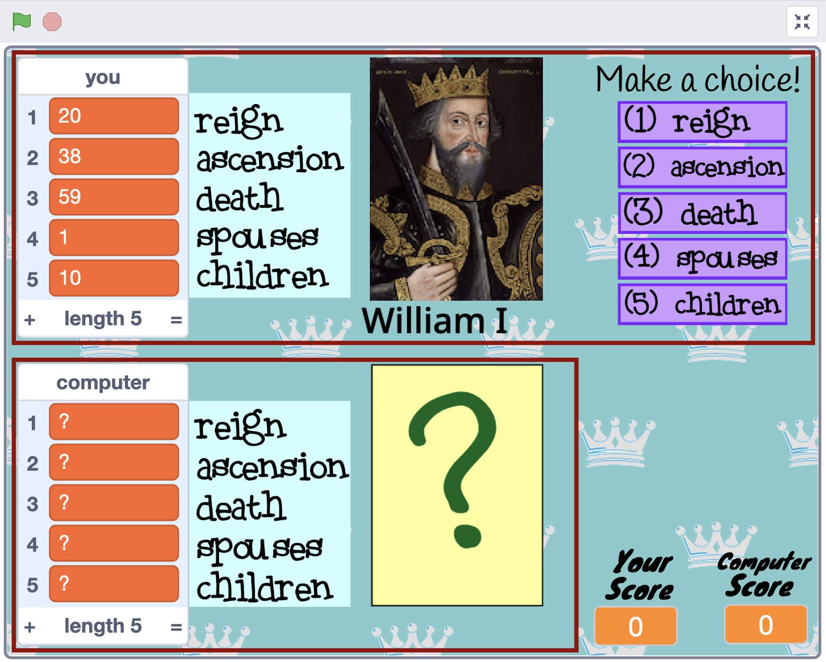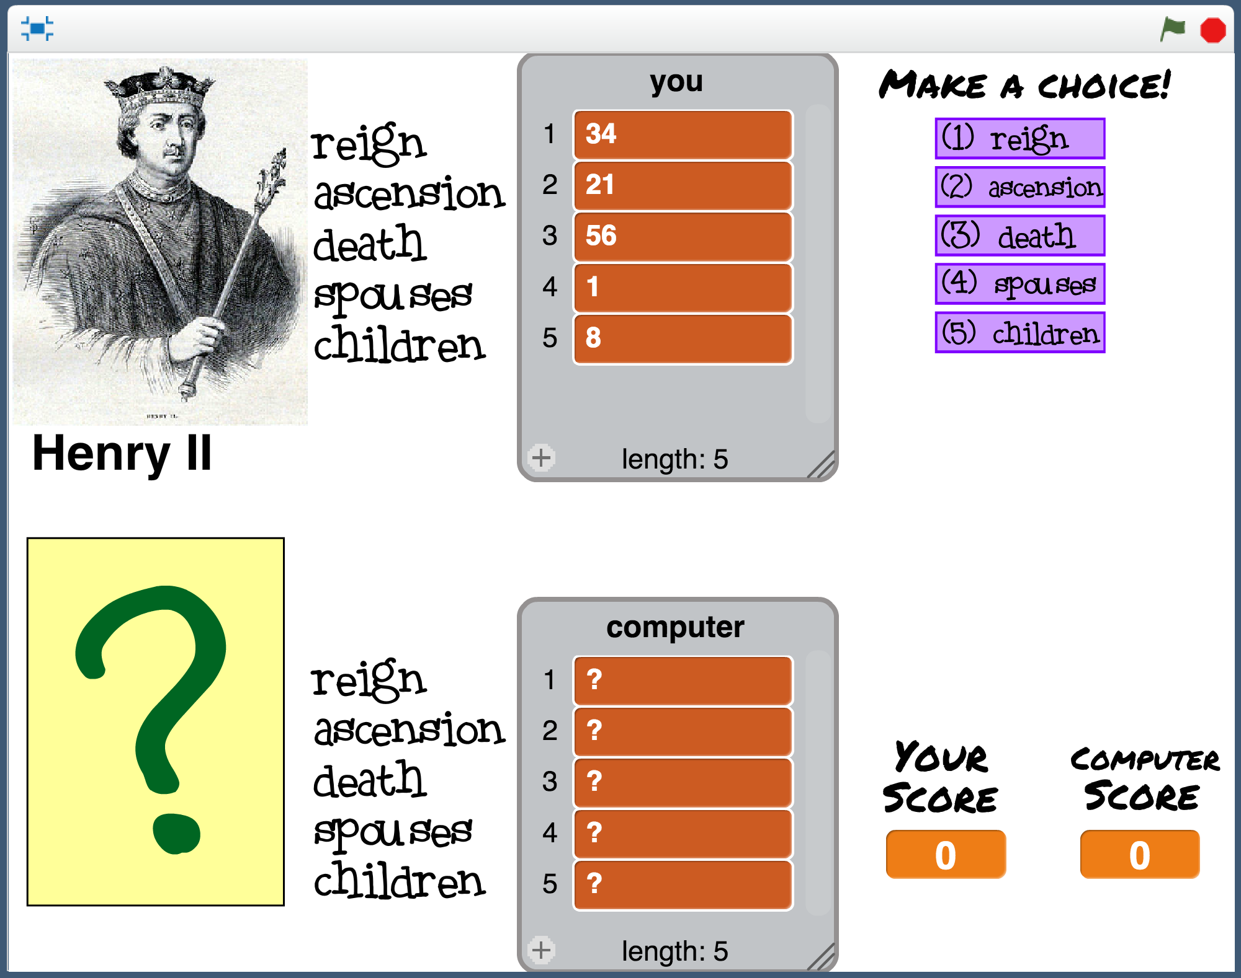Click the **green flag** to start   
    The top half of the screen is you.   
    The bottom half is the computer.  
       
    When you click the Green Flag to start, you can’t see the computer’s card yet.   
      
    It’s all just question marks.   
      
    Choose a value from your king or queen by **clicking the purple button next to it**  
      
    When you choose, the computer card is revealed, and you see if you won or lost.   
    The score in the bottom right corner is updated.   
      
    Click on the green Next button to move onto the next card and play again.  
    If you win or tie, it’s your turn again.   
    **If you lose, the computer will get to choose the next value instead.**
18. Play a few rounds of the game against the computer.  
    *Try to work out how the computer is choosing values to play.   
    When you think you’ve worked out how the computer is playing, move onto the next step.*
19. Click on the **full-screen** button again to go back to normal view.   
    Then click on the **Stage** 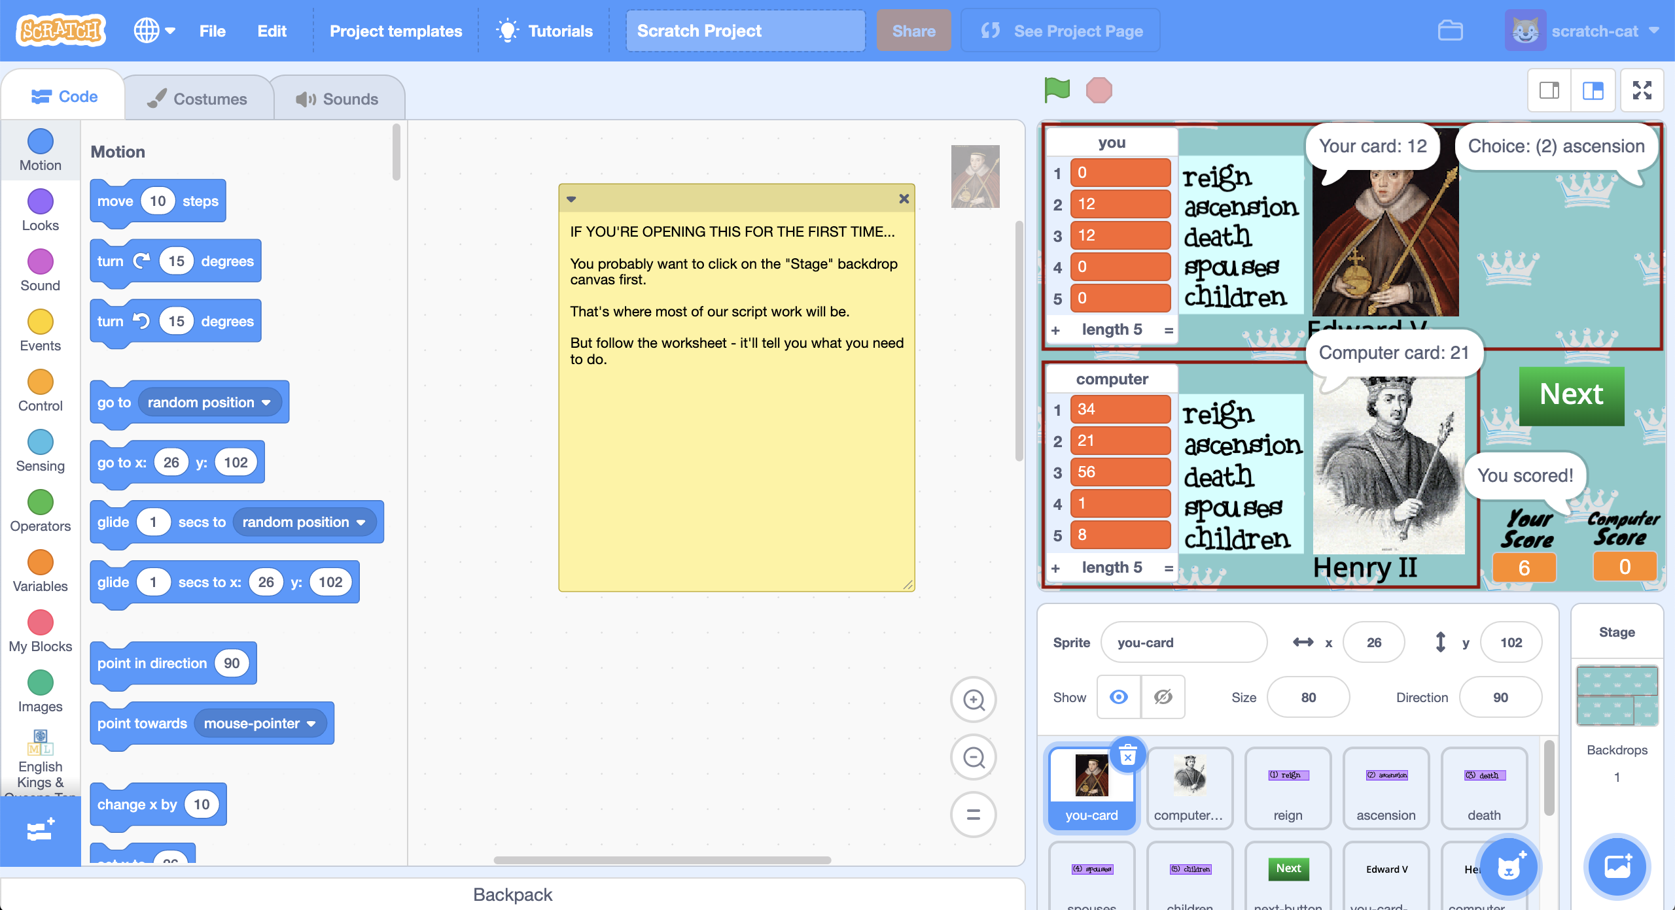
20. The script on the **Stage** shows how the computer has been coded.  
    **The computer always picks “reign”.**   
    *Did you get it right?*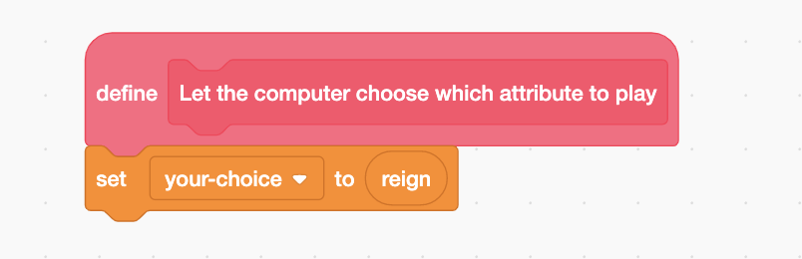
21. Change the script so that the computer chooses a value at random when it’s the computer’s turn.   
    *Choosing from 1 (reign) to 5 (children) at random.*   
    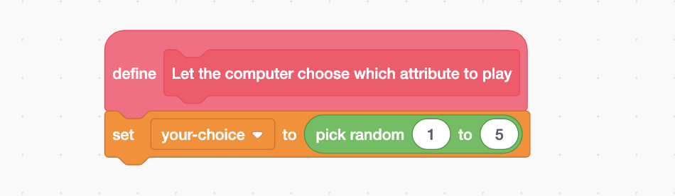
22. Click the **green flag** to reset the scores to 0. Go back to full-screen and play the game again.   
    *Stop when either you or the computer reaches 10 points. Who won?*

**What have you done so far?**

You’ve set up a bot to play Top Trumps and given it a simple strategy: choose values at random.   
  
But people don’t play like that. We learn how to choose which value would give us the best chance of winning. We do this based on the cards we’ve seen before, and on our understanding of the rules.

Next, you’ll create a Scratch script that collects training examples using the moves that you make.

1. Still on the **Stage**, drag the “**add training data**” block to the canvas  
   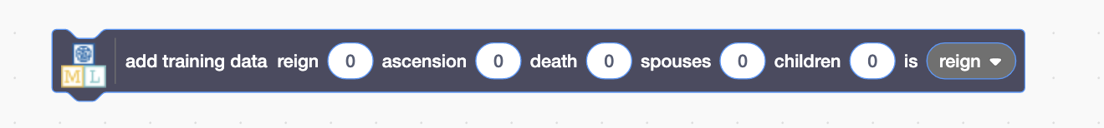
2. Add the values from your card to the block  
   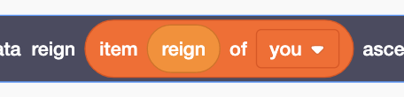 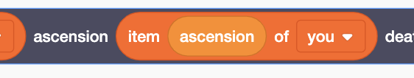 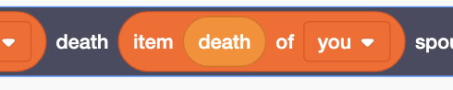 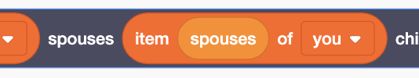 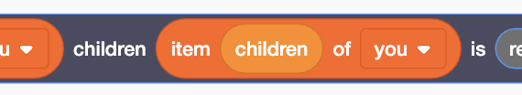
3. Surround the “add training data” with an “**if**” block like this:  
   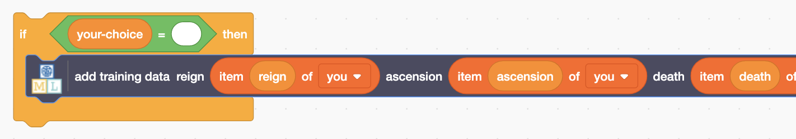
4. Duplicate it five times – once for each possible choice of value  
   *Right-click on the “if” and then choose “Duplicate”  
   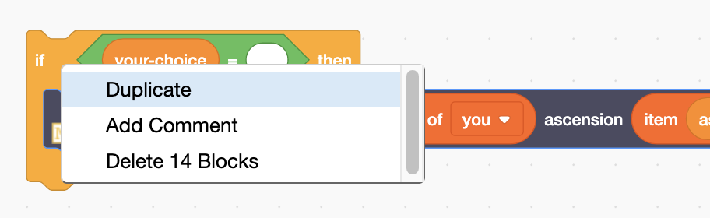*
5. Add the choices to each if block  
   *“if” choices should use orange options from “Data”*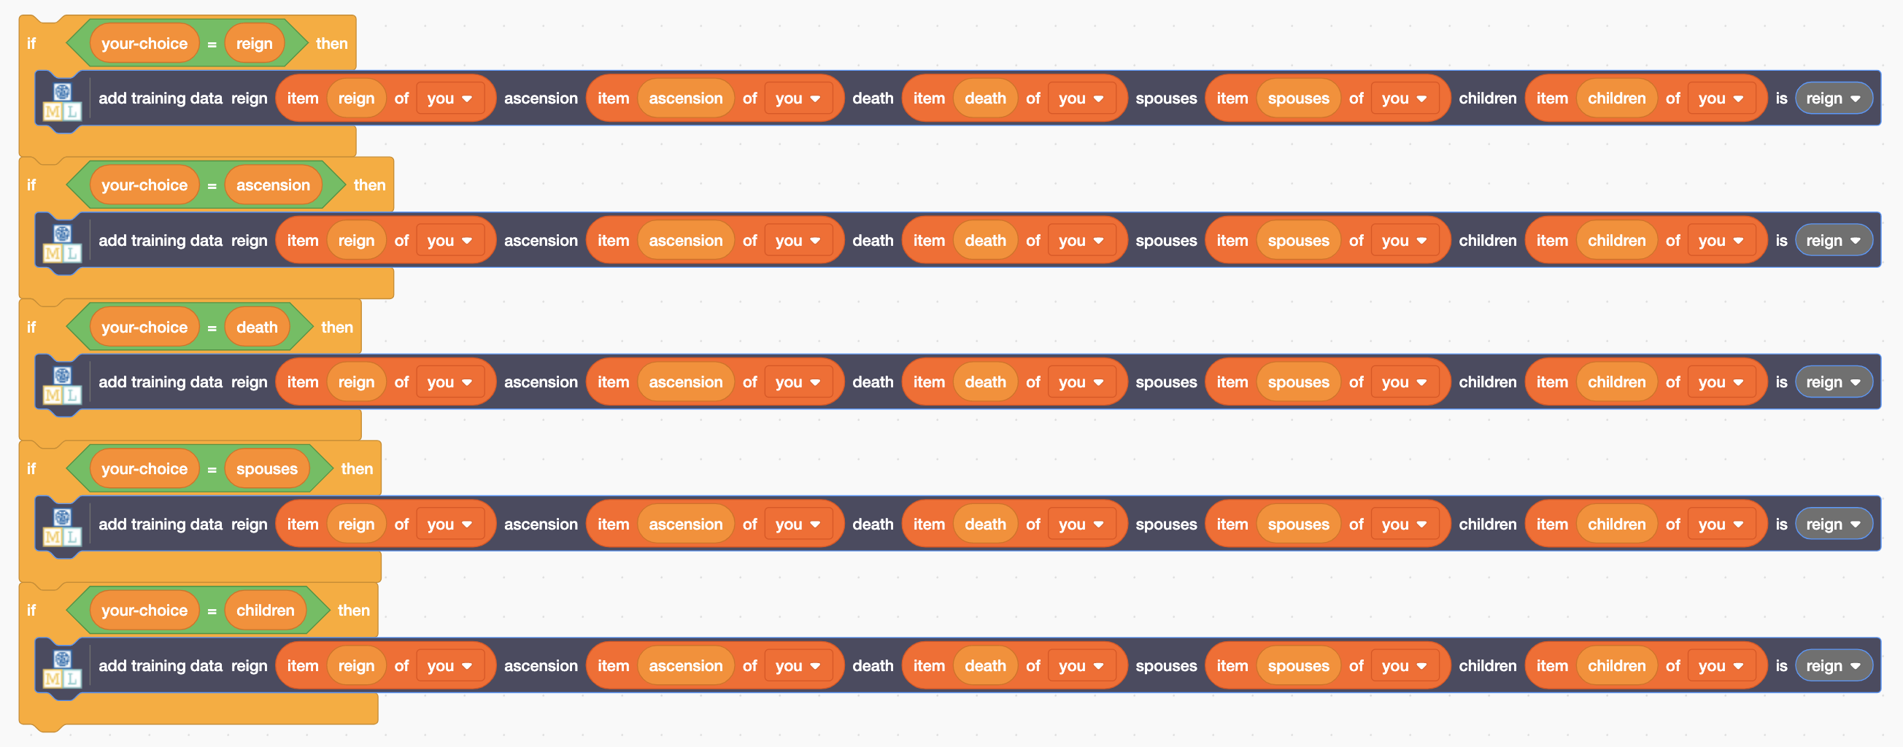
6. Choose the matching choice for each “**add training data**” block 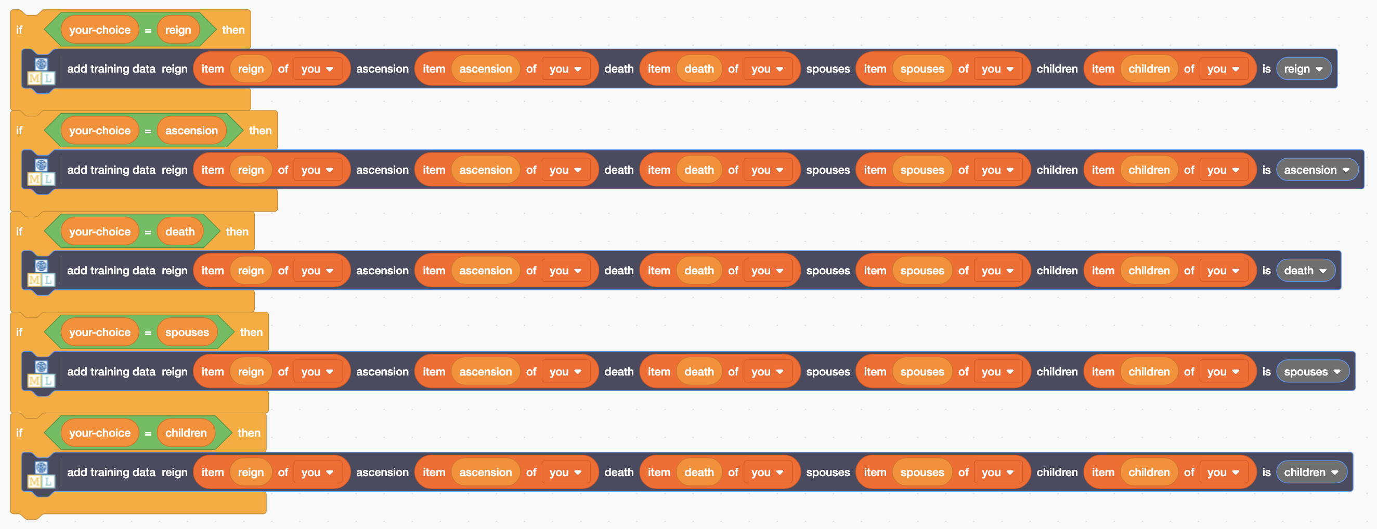
7. Finish the script so that this is called every time you win a hand  
   *The values that were on your card, and the choice you made, will be added to the training examples every time you win.*  
   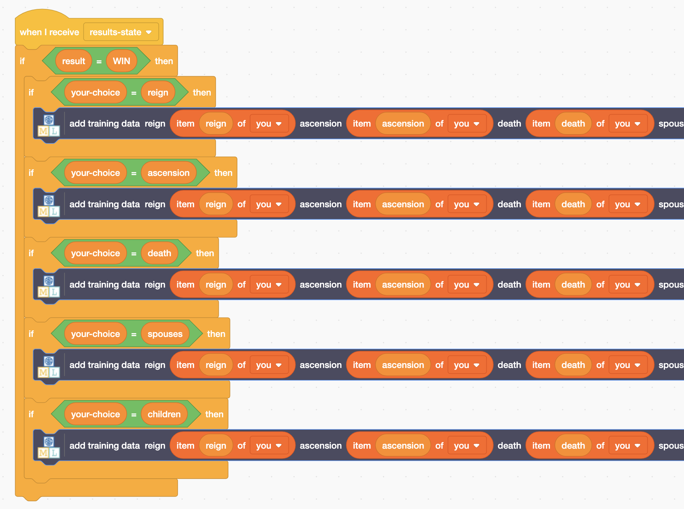
8. Click the full-screen button and green flag again.   
   Play games until your score reaches **10**.
9. Save your project  
   *Click “****File****” -> “****Save Project****”*  
   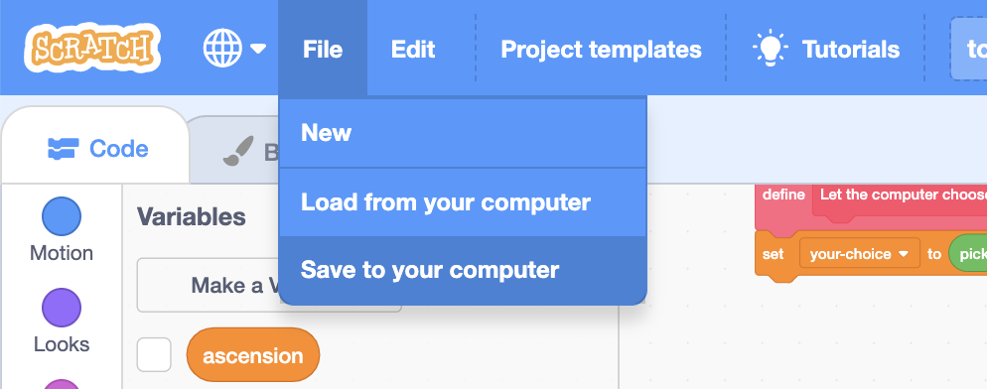
10. Leave the Scratch window open.   
    In the training window, click the “**< Back to project**” link.
11. Click the “**Train**” button
12. Check your training data  
    *The ten winning moves that you made should have been added to your training examples.  
    Each example contains the numbers that were on your card.   
    The bucket (that the example is in) is the winning choice that you made.*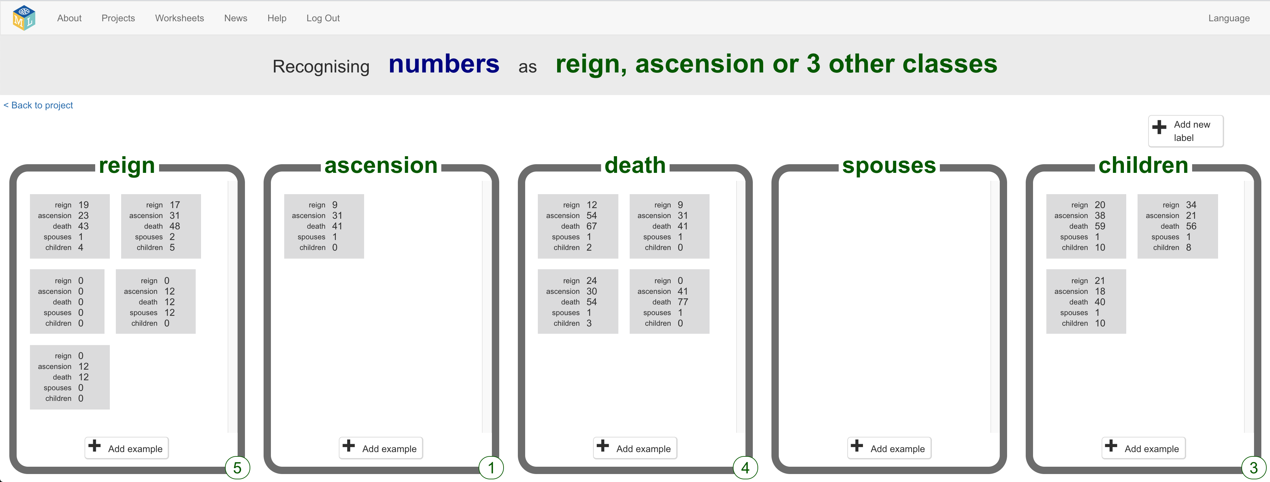
13. Click the “**< Back to project**” link. Then click “**Learn & Test**”
14. The training page won’t let you train a model yet   
    *The ten examples aren’t enough yet to train a model.*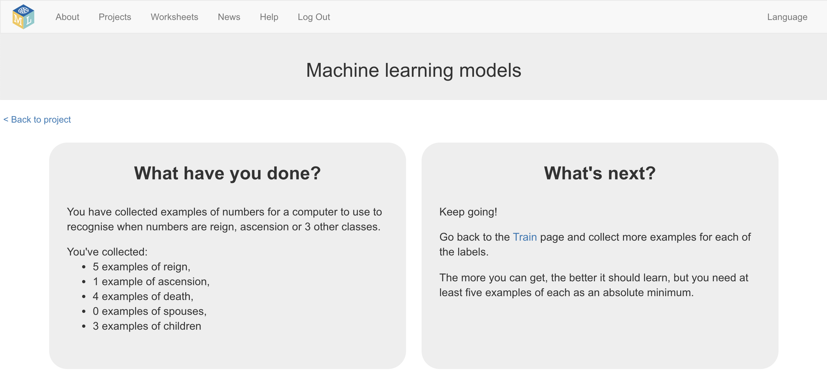
15. Leave the page open.   
    Go back to your game in Scratch and play more games.
16. After a while, go back to the “Machine learning models” page, and refresh the page.   
    Keep doing this until you’ve got enough examples for the “**Train new machine learning model**” button to appear.   
    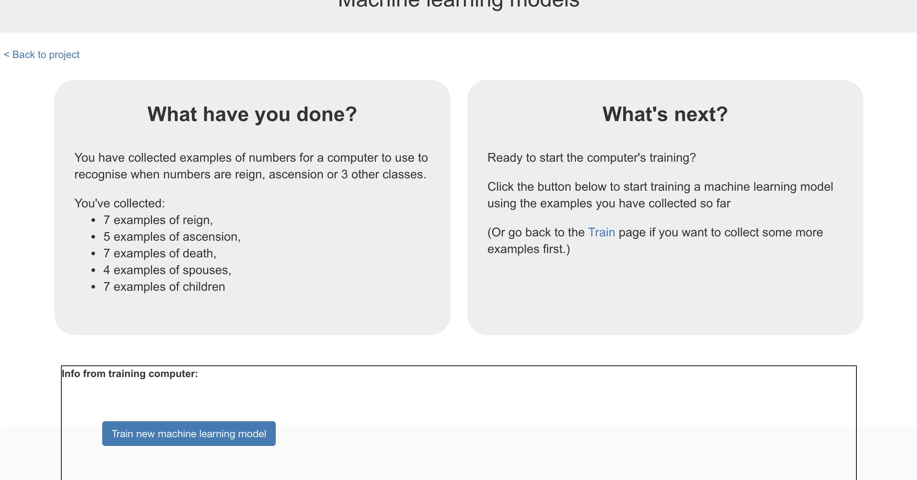

**What have you done so far?**

You’ve started to train a computer to learn about Top Trumps.

The examples help the computer learn what values to expect in cards: the range of numbers for each value, how often it should expect to see high values, how often it should expect to see low values.

The examples also help the computer to learn what numbers are likely to help it to win, without you needing to tell it what the rules are.

1. Go back to the Scratch window
2. Click on the “**Stage**” to get to where you added the scripts before
3. Add the “recognise numbers … (label)” block  
   
4. Add the values from the computer’s card to the block  
   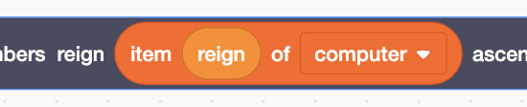 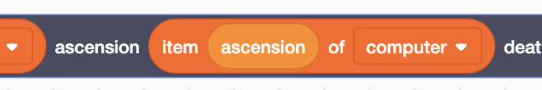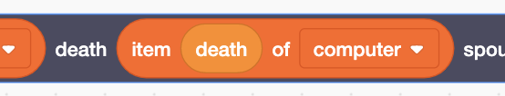 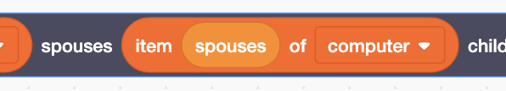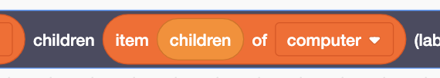
5. Add it to an “**if**” block to get a script snippet that looks like this:  
   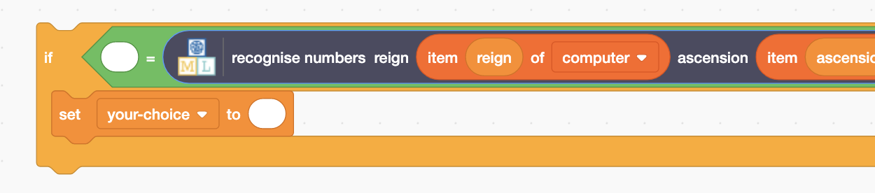
6. Right-click on the “if” block and click on “**Duplicate**”  
   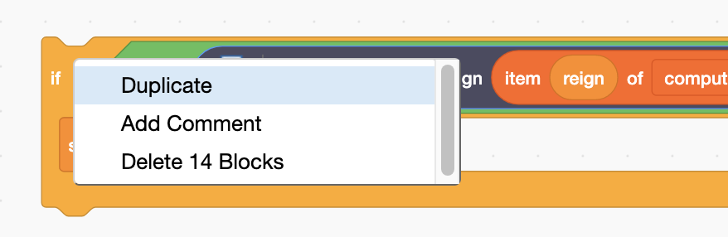
7. Repeat the duplicate until you have **5** copies of the if block, joined together.
8. Copy the orange variable blocks for each choice into the   
   “**set your-choice**” blocks  
   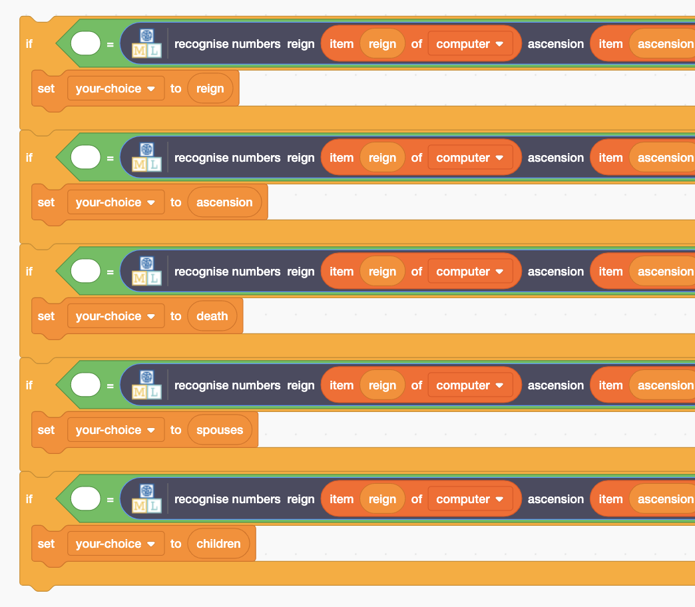
9. Copy the machine learning bucket blocks into the “**if**” blocks  
   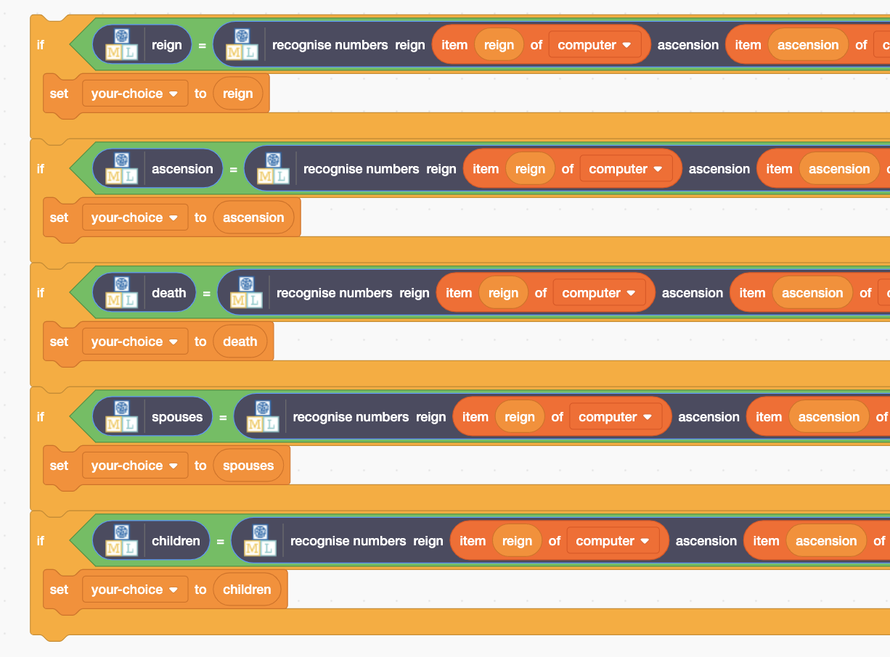
10. Replace the contents of the “**Let the computer choose which attribute to play**” block with your new machine learning script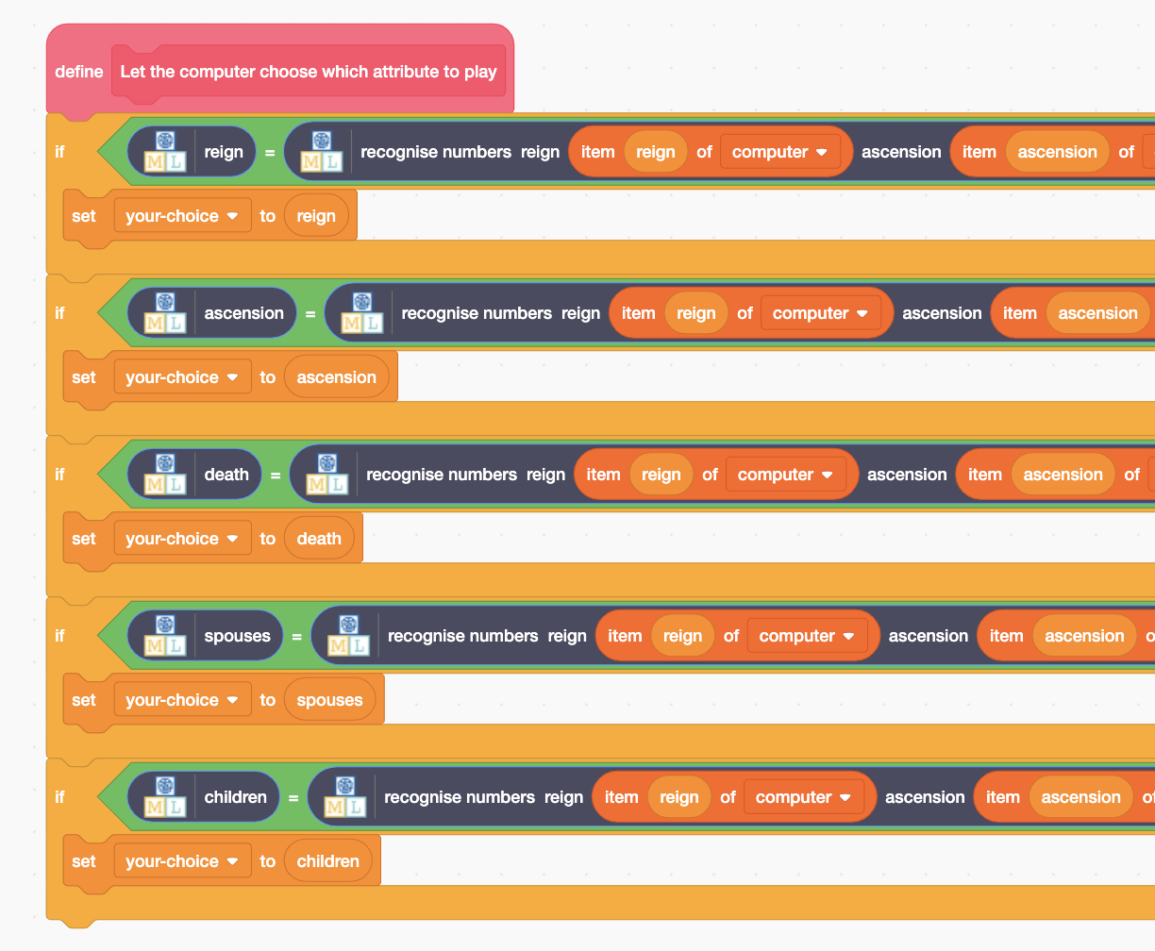
11. Save your project  
    *Click “****File****” -> “****Save to your computer****”*
12. Click the **Green Flag** and play against your machine learning model  
    *Play until you reach the score of* ***20***

**What have you done so far?**

You’ve modified your Scratch Top Trumps bot to use machine learning instead of your earlier random approach.

You haven’t collected nearly enough examples to train a good model yet. The computer won’t have seen enough examples of the game being played to have learned the types of values to expect, or the values that are more likely to win. Its predictions will often be wrong.   
  
To get better, it needs more examples. Lots more examples.

1. Go back to the training tool window
2. Click the **“< Back to project**” link, then back to “**Learn & Test**”
3. Click the “**Train new machine learning model**” button   
   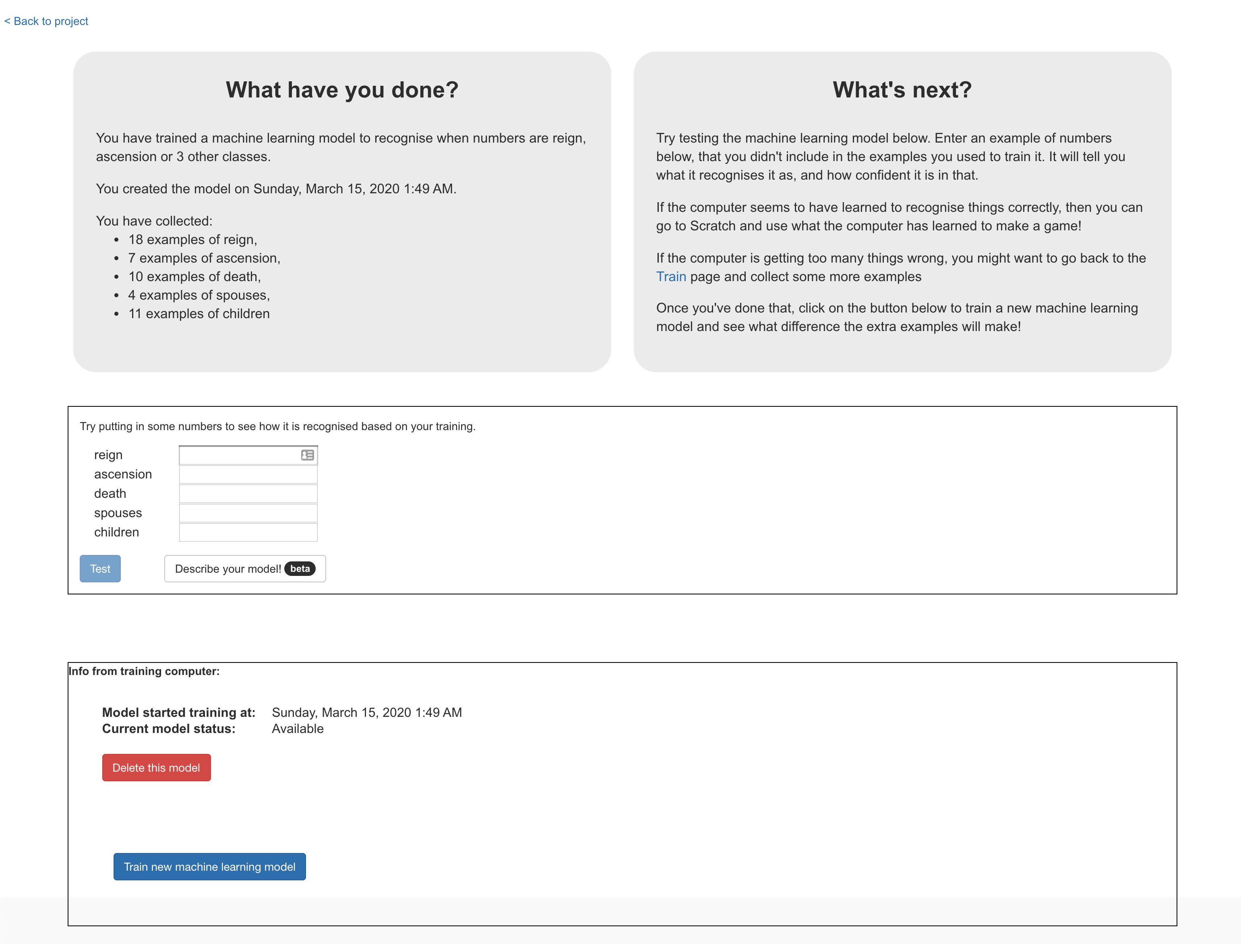
4. Switch back to the Scratch window.   
   *If you accidentally closed it, you can get back to it by doing this:  
   * Click the “****< Back to project****” link  
   * Click the “****Make****” button  
   * Click the “****Scratch 3****” button  
   * Click the “****Open in Scratch 3****” button  
   * Open the file you saved before, with “****File****”->“****Load from your computer****”*
5. Play the game again.   
   *Is it getting any better? Does the computer win more often now?*
6. Repeat steps 51 – 55 to collect more examples, and then train a new machine learning model with them. Do this a few times.

**What have you done so far?**

The computer is only learning from the decisions that you make. To speed up the collection of training examples, next you’ll let the computer learn from its own moves as well.

1. Open the game in Scratch
2. Find the “**When I receive ‘results-state’**” script in the Stage   
   that you made earlier  
   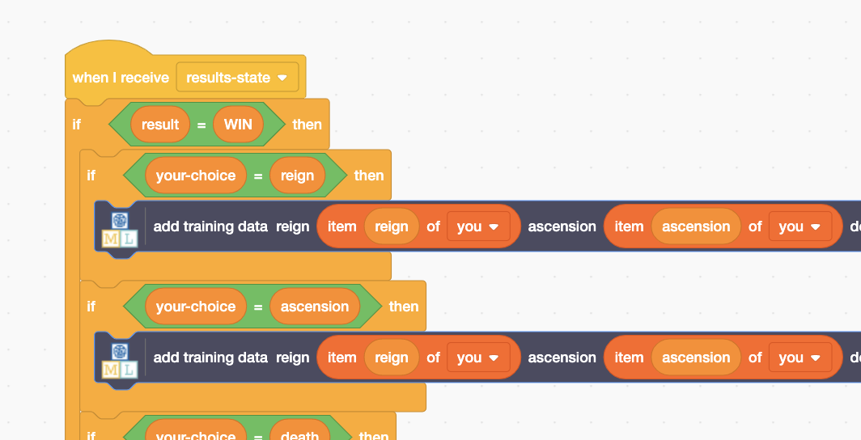
3. Duplicate the “**if result = WIN**” block
4. Modify the duplicate so that it says “**if result = LOSE**” at the top  
   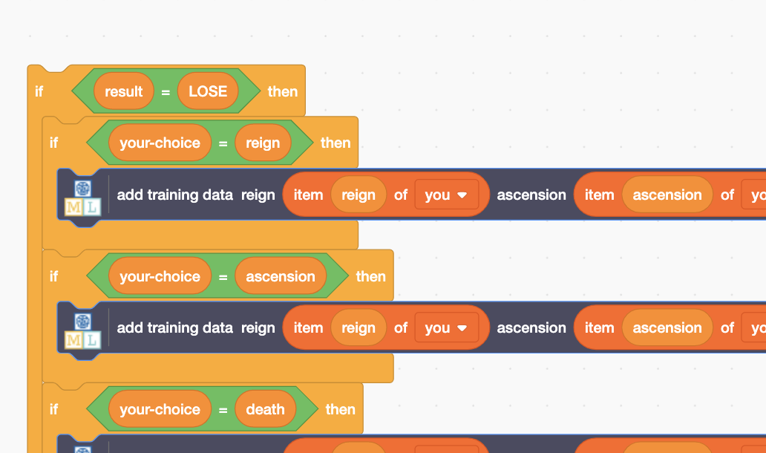
5. Modify the duplicate again, so that the computer’s moves can be added to the training examples when the computer scores a point.   
   *Change the “you” to “computer” (to get values from the computer card)  
   for all five “add training data” blocks*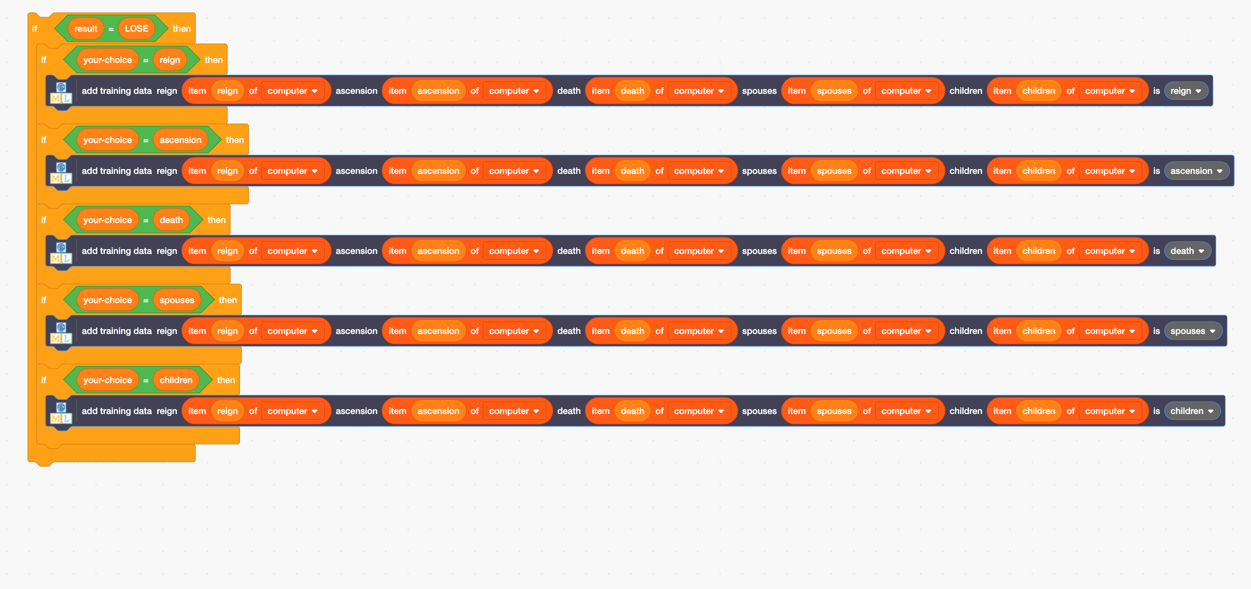
6. Join it all up  
   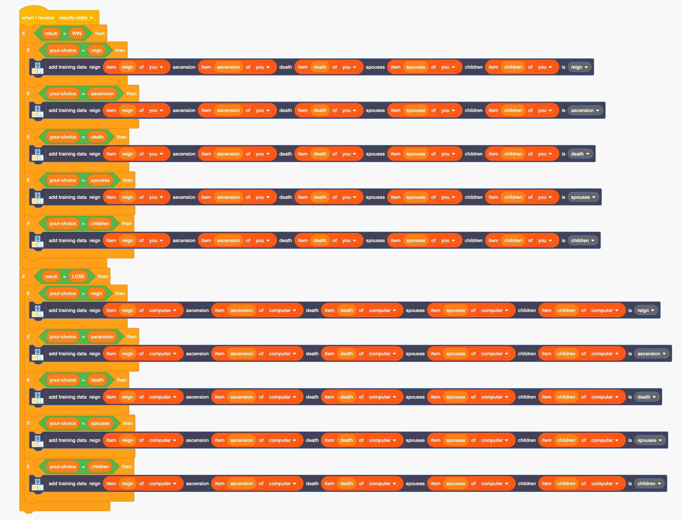

**What have you done?**

You’ve made a Top Trumps bot that can learn by playing the game. This means you don’t need to wait for the computer to have learned before it can start playing. It can start playing (even if it loses a lot at first), straight away. And by playing the game, it will learn from those experiences how to get better.

You haven’t told the computer what to do, but allowed it to try out different choices and discover what choices are more likely to help it to win.

This is called “reinforcement learning”. When it makes a good choice, this is reinforced by the computer being told that it has won.

**An example of training a Top Trumps bot**

*Your results will be different to this.*

*But these were the results I got from training my bot.*

|  |  |  |
| --- | --- | --- |
|  | **Score** | |
| **Human** | **Computer** |
| No training – computer choosing at random | 72 | 28 |
| Trained with 100 examples | 47 | 53 |
| Trained with 200 examples | 38 | 62 |
| Trained with 300 examples | 29 | 71 |
| Trained with 400 examples | 25 | 75 |
| Trained with 500 examples | 27 | 73 |
| Trained with 600 examples | 29 | 71 |
| Trained with 700 examples | 27 | 73 |

*In general, more training is better.*

*There were times where the computer did worse after more training.*

*Why do you think that was?*

*After a certain point, the computer’s scores stopped improving, even after I kept adding more and more training.*

*Why do you think that was?*

*Compare these results with the results from your bot. How has your bot learned from the training you’ve given it?*